**Assignment for Jio Games GUI (Graphical User Interface)**

Here I have added description about design what I have done:

In First screen, I have taken ViewPager and Recyclerview with Carousel for Horizontal and Vertical Scroll view.

ViewPager: ViewPager allows user to flip left and right. Inside a scrollview, I have created simple Carousel, so we can scroll horizontally.

RecyclerView: In our app, we want to display a scrolling list of images with text, so I have used RecyclerView for it. It is more advanced and flexible version of ListView.

For that, I have used library – gravitysnaphelper, which is providing snapping support during scrolling to start, top, end or bottom using GravitySnapHelper class.

Using this Library, we can scroll images with Title.

I have created Navigation Drawer and Action bar to display options like Search, View & Highlight.

To display data and image, I have created file ‘details.json’ and stored it into assets folder. I am fetching data and images using JSON.

In Second Screen, I have used Slide Up Bar and I have used library ‘slideuphelper’. It allows me to add slide effect on view in Bottom. I have customized a view as well.

I have added all screenshots which is showing how app looks.

**Here is details.json, which is added in asset folder:**

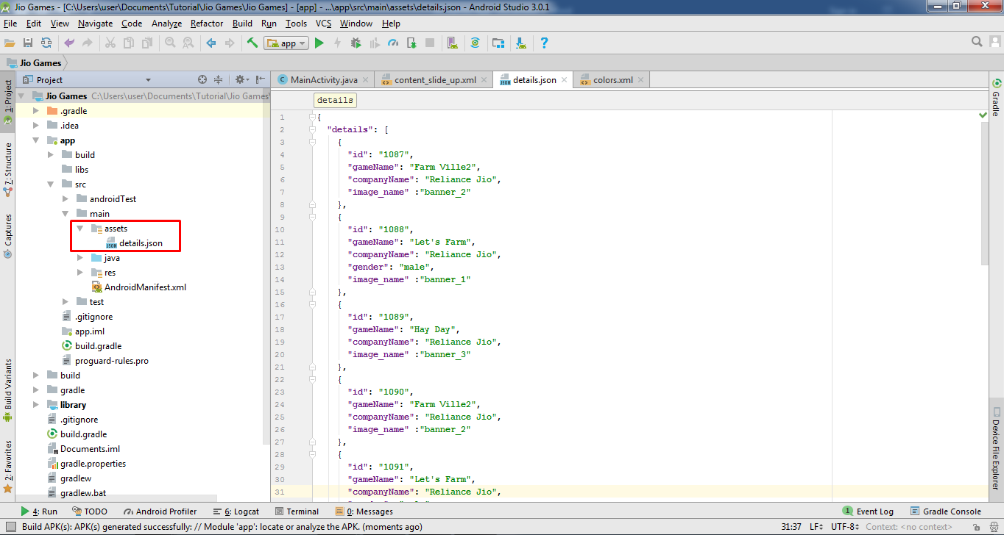

details.json

This screen is about Logo and App name.

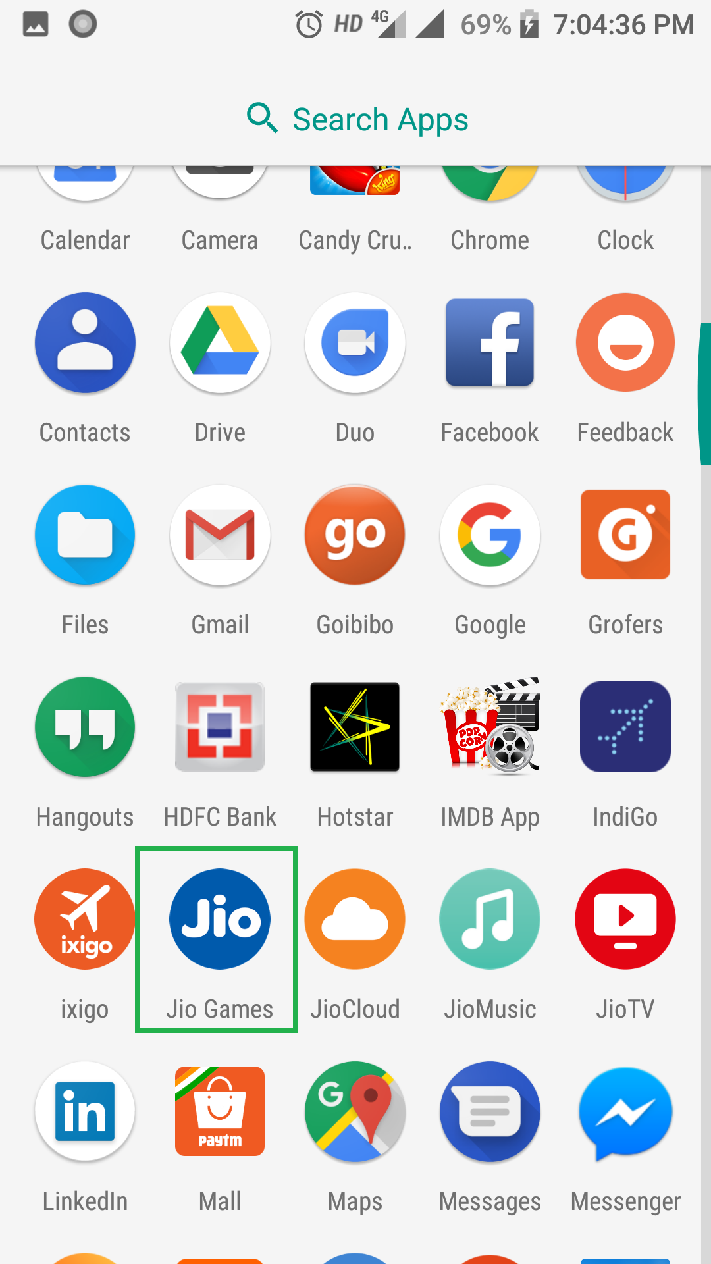

This screen is about Main Screen.

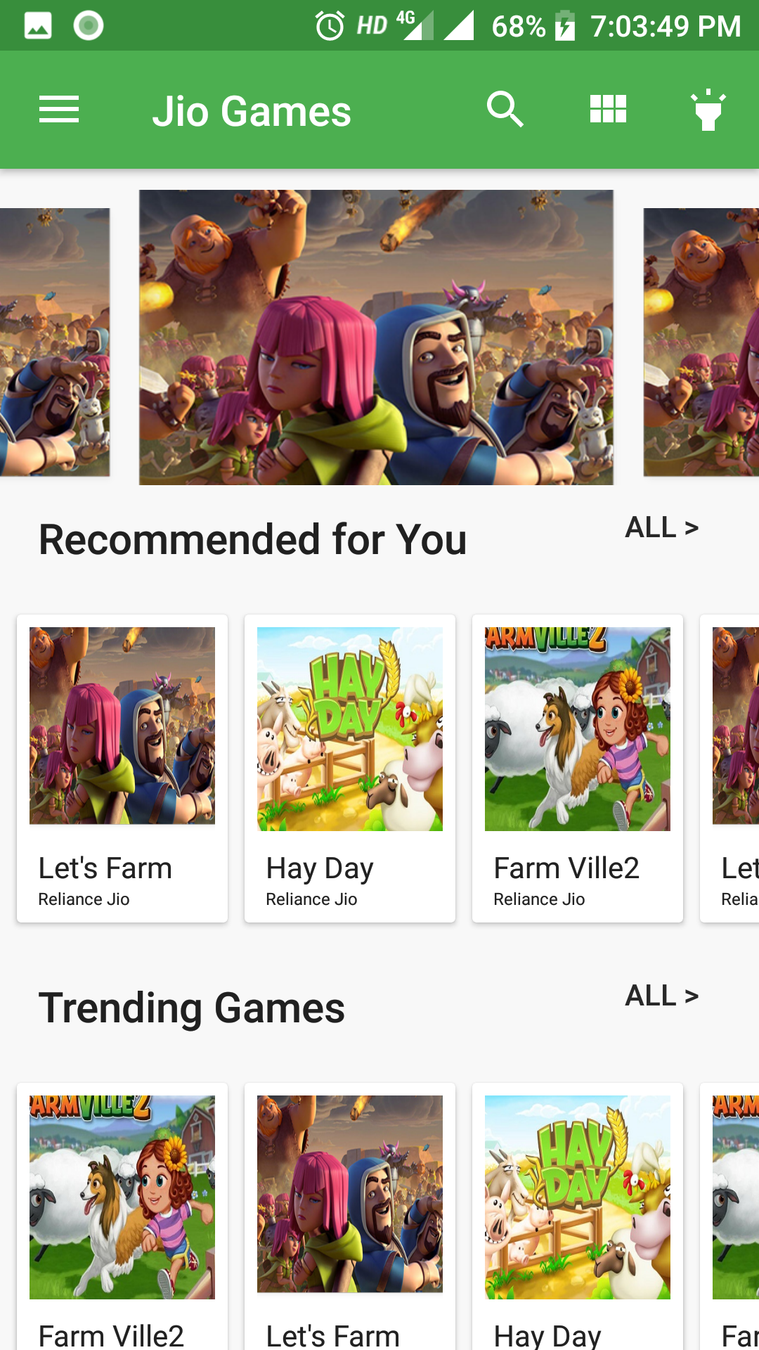

**This screen is about scrolling Horizontal Scrolling.**

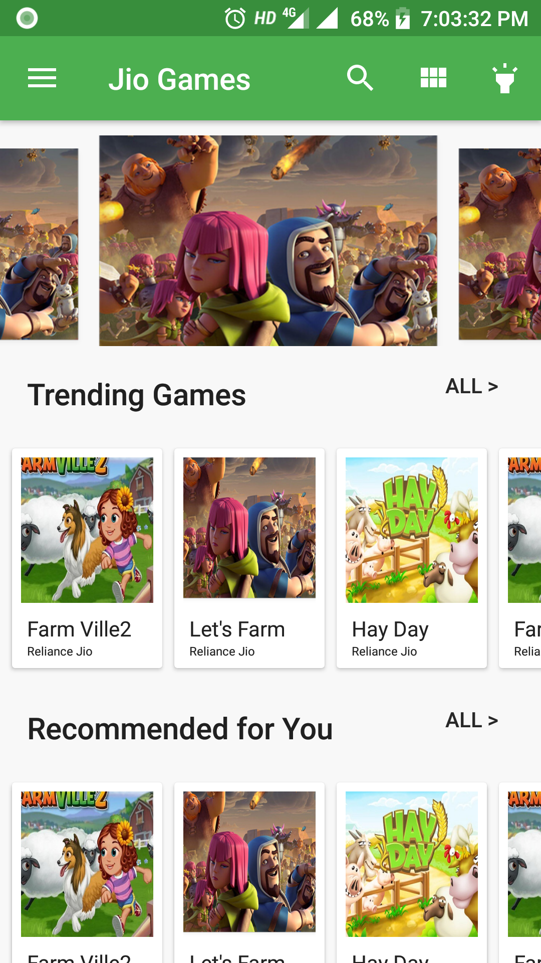

**This screen is about Vertical Scrolling.**

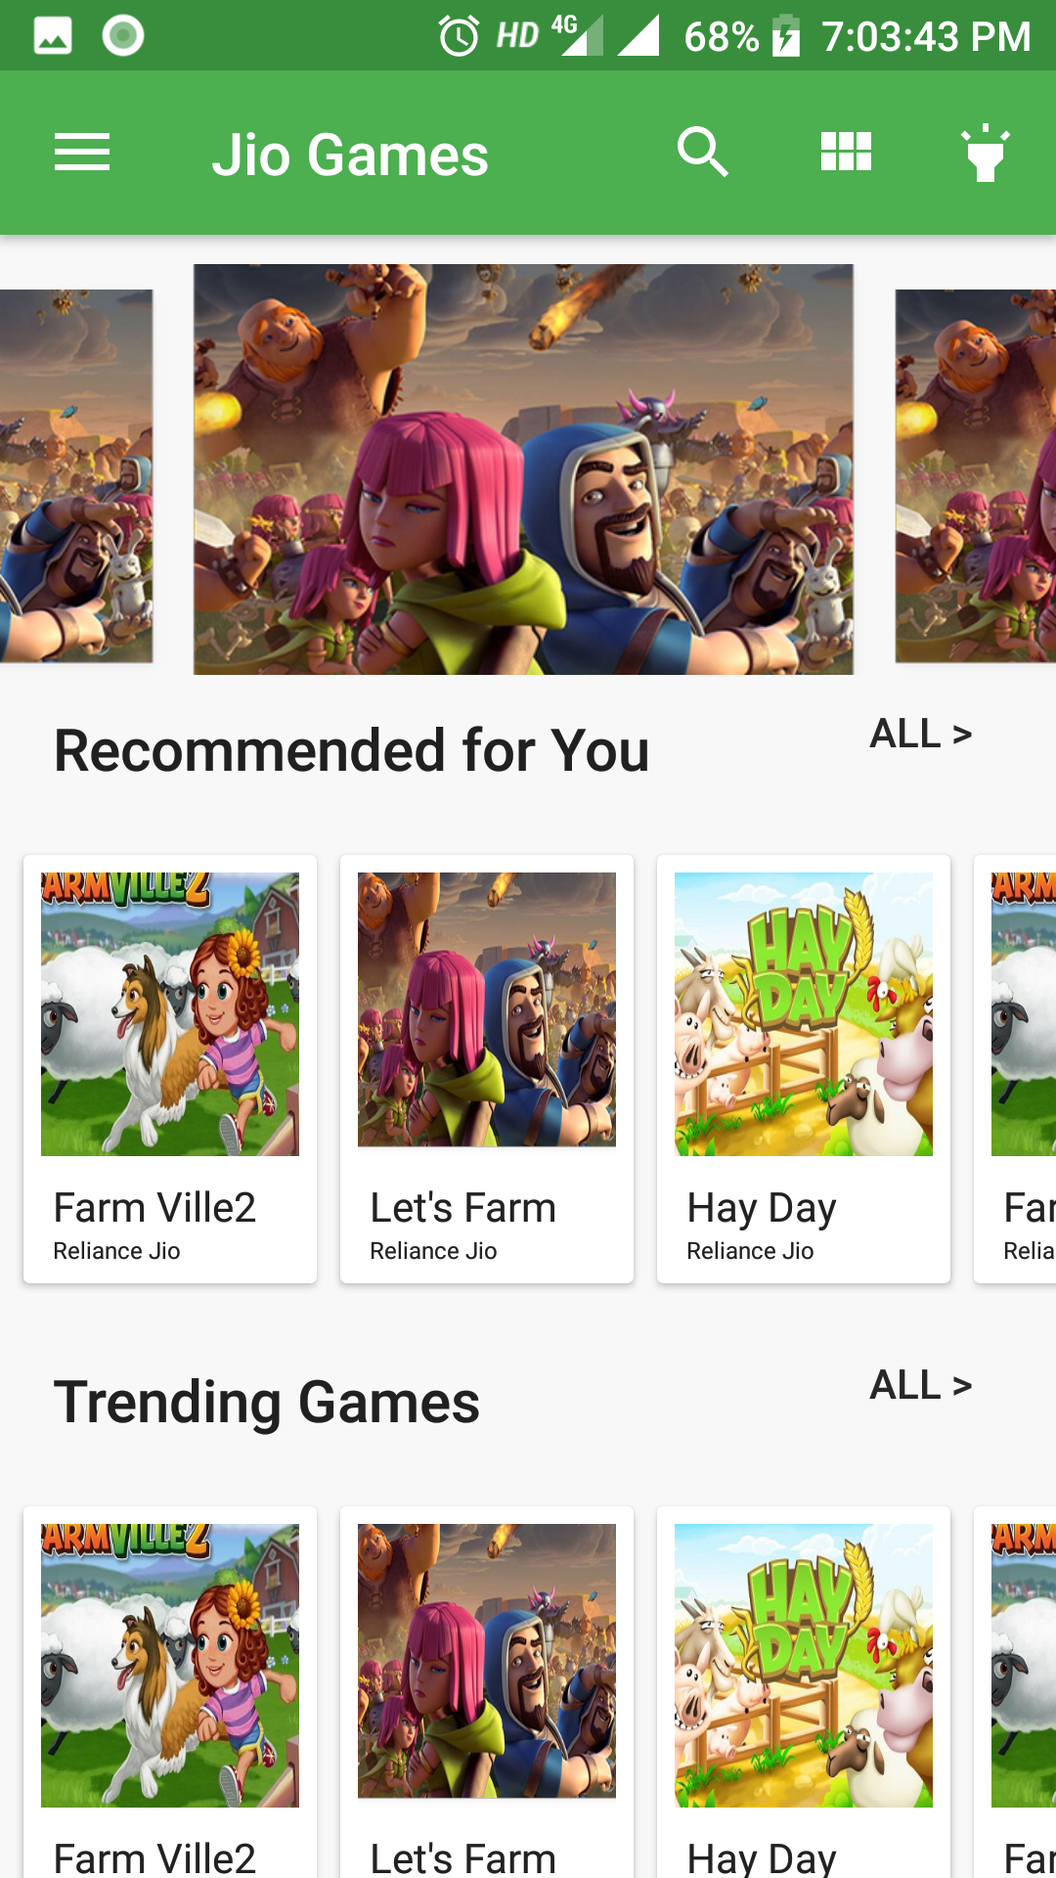

**This Screen is about Slide up bar, which is opening in the same screen.**

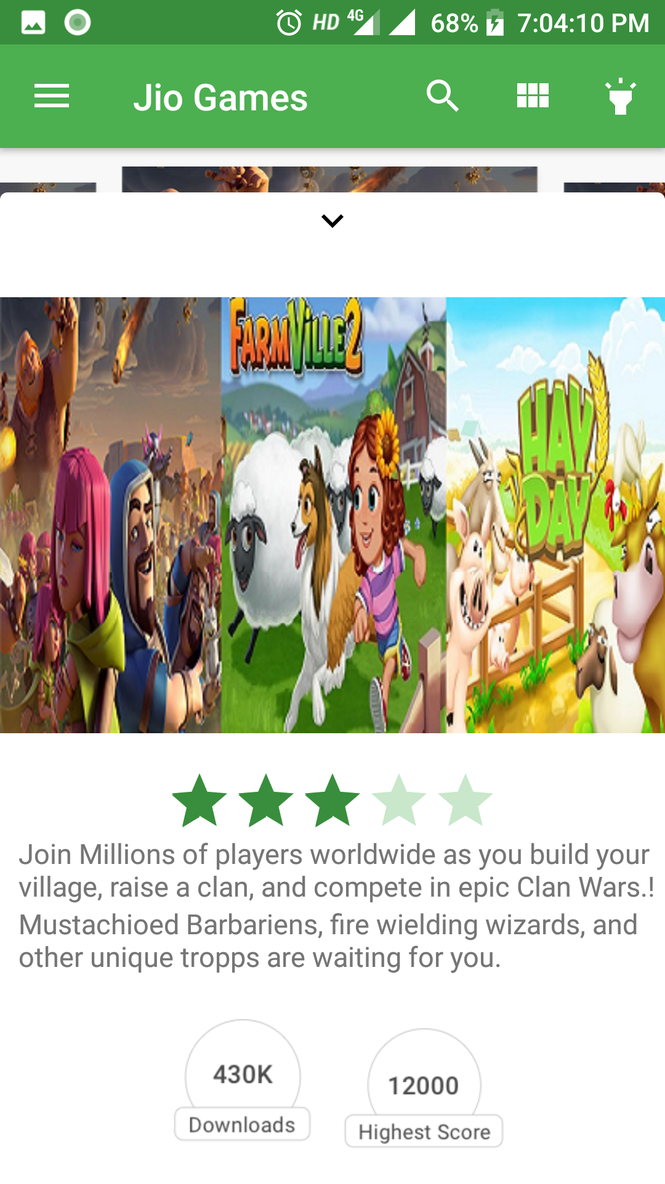

**This screen is about Navigation Drawer of App.**

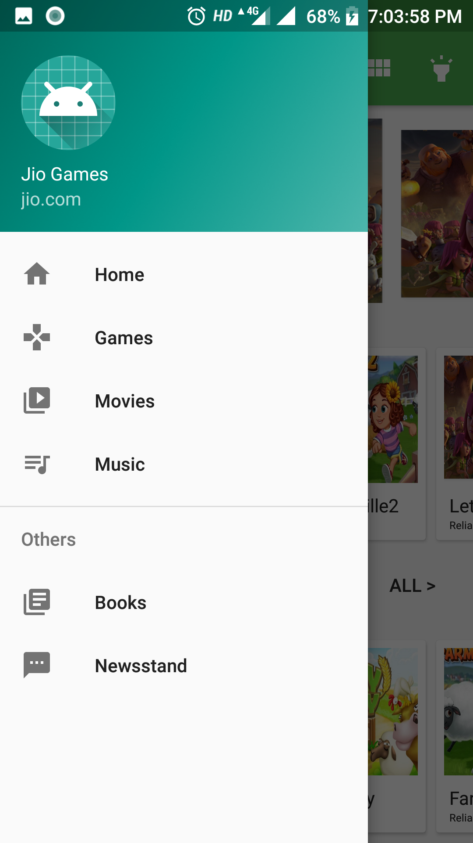

**Conclusion:**

It was a great experience to work on this Jio Games sample app. Many things I learnt during development. I wish you would like my work. Thank you.